**Create your own new custom VPC**

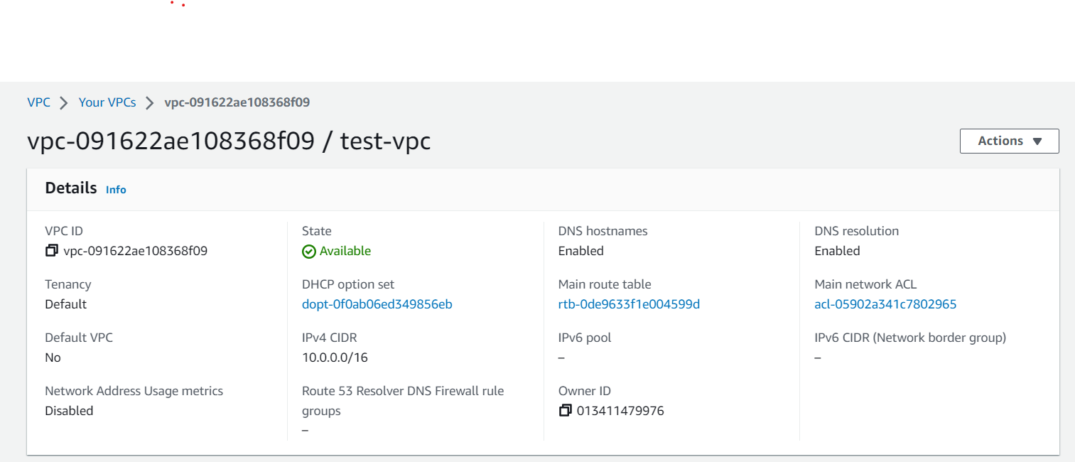

**- And configure your EC2 linux instance inside your custom VPC**

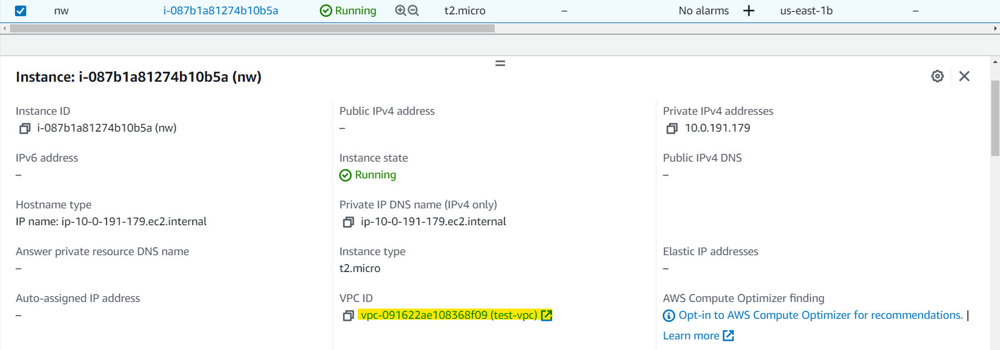

**- and then create 3 subnets of that VPC**

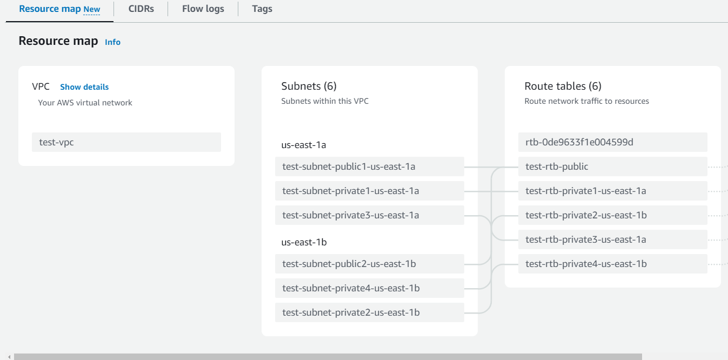

**- Attach an internet gateway to your custom VPC**

